1. Identify the most expensive and affordable cities for Airbnb hosting and give suitable reasons.

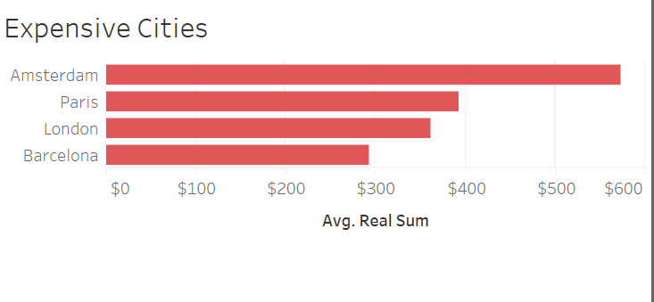

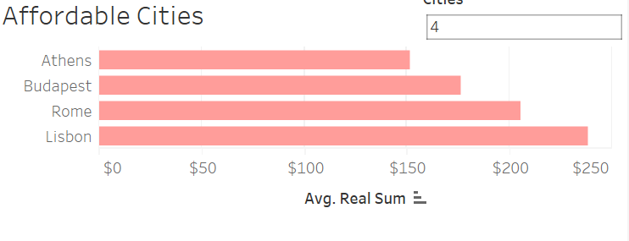

From this dashboard and screenshots we can get to know that Amsterdam, Paris, London are the top 3 expensive cities. Athens, Budapest, Rome are 3 affordable cities. By changing the number of cities, we can get the top N expensive/affordable cities. Amsterdam, Paris and London are probably expensive because they are tourist destinations and there is lot of demand.

1. Compare differences between weekday vs weekend booking patterns to project rental rates comparison in European cities. Give suitable reasons.

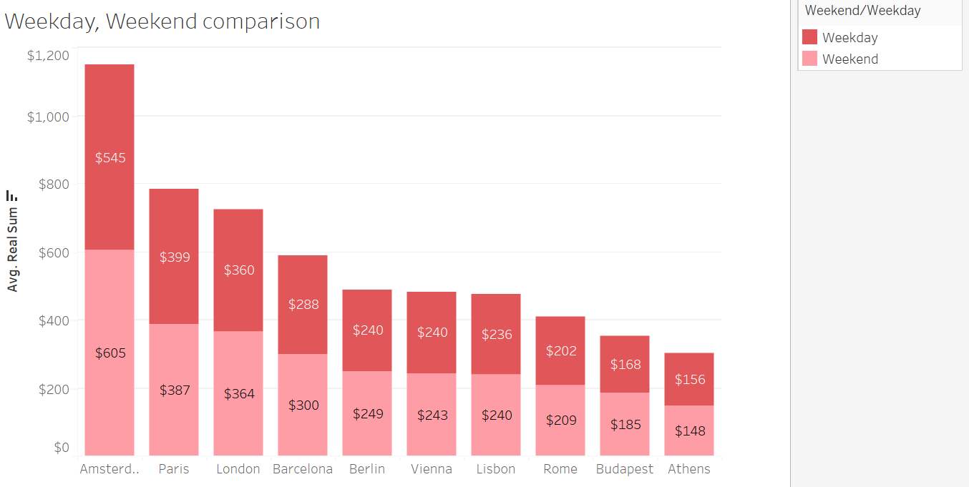

This graph shows that the average weekend real sum is greater than that of weekdays for all cities except for Athens. Bookings during weekends is more than weekdays booking. There is particularly a significant increase in average real sum during weekends in Amsterdam.

1. Identify important determinants of Airbnb prices (avg. guest satisfaction, avg. cleanliness) to provide insights into areas of opportunity for improvement concerning vacation rentals.

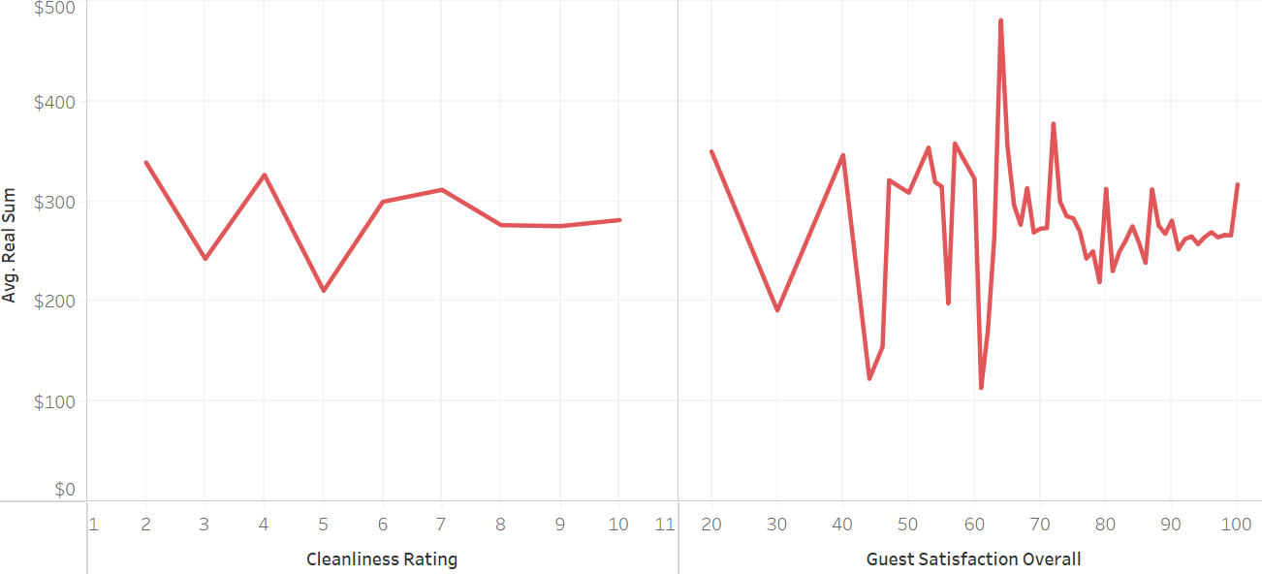

Although for some accommodations, cleanliness rating is low, the average real sum is still high. The accommodations having less cleanliness rating and high cost can reduce the cost a bit and improve the cleanliness. There is not much significant data regarding average real sum and guest satisfaction. Entire home/apartment are more expensive but are preferred due to privacy and other amenities.

1. Identify the important drivers in Sales/Booking occupancy across different cities.

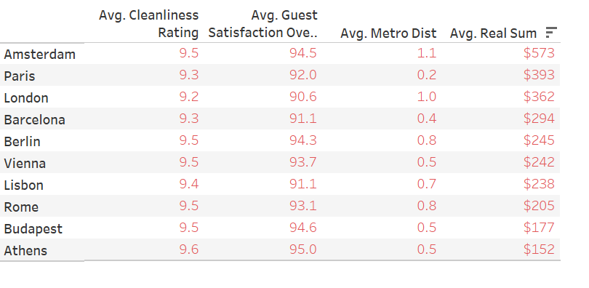

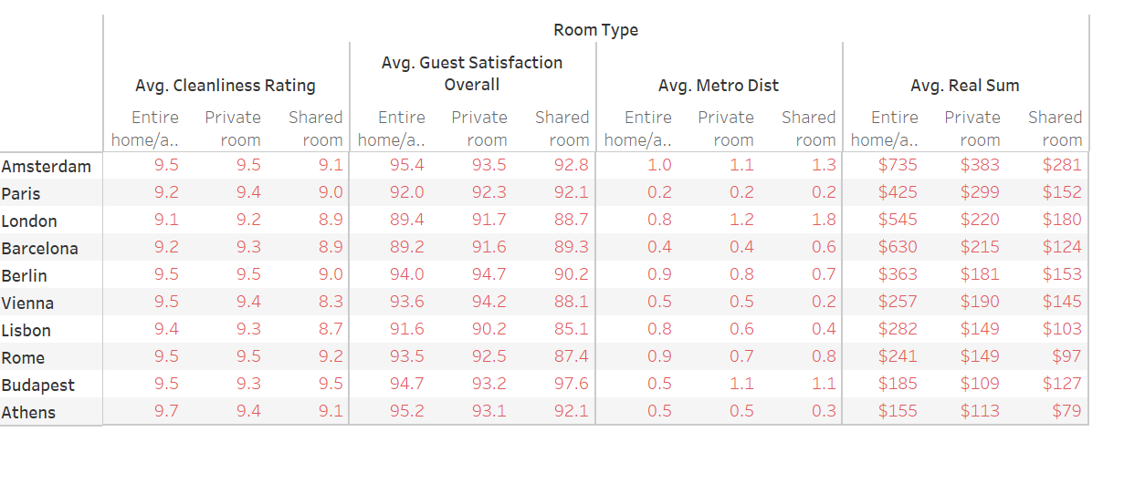

Generally, for shared rooms, the cleanliness and guest satisfaction are lesser than private rooms and entire house/apartment. This is because room is shared. To ensure good rating, the shared rooms need to be cleaned more often by housekeeping labour. Entire House/Apartment is most preferred because it offers privacy. Accommodations can have more entire house/apartment or private room to increase number of customers.